

OVERVIEW
The McKinney-Vento Act defines and protects the rights of students in transition to enroll in, attend, and succeed in our public schools. Chattooga County Schools was approved by the State Board of Education for a three-year grant cycle of the Education of Homeless Children and Youth grant in 2010-2011 for an award amount of $42,062. The Evaluation summarizes the assistance provided during the 2010-2011 grant cycle.

DEFINITION
The McKinney-Vento Act provides educational services to any pre-school or school-aged student who lacks a fixed, regular, and adequate nighttime residence. The term transient includes:
- Children and youth who are sharing the housing of other people due to loss of housing, economic hardship, or a similar reason—“doubled up”
- Children and youth who are living in motels, hotels, trailer parks, or camp grounds due to the lack of alternative housing
- Living in emergency shelters or transitional shelters
- Abandoned in hospitals
- Awaiting foster care placement—temporary (approximately one year or less)
- Children and youth who have a primary nighttime residence that is a public or private place not designed for or ordinarily used as a regular sleeping accommodation for human beings
- Children and youth who are living in cars, parks, public spaces, abandoned buildings, substandard housing, bus or train stations, or similar settings
- Migratory children described in the above situations
- Unaccompanied youth are youth not in the physical custody of a parent or guardian.

EVALUATION
Three schools utilized after-school tutoring services through McKinney-Vento funding proving to be the most successful activity shown by the improvement in student report cards and Graduation Test achievement. Of the 44 transient students receiving tutoring, 70% showed an increase in at least one letter grade quarterly. At the high school, 7 transient students out of 13 (54%) total passed the Graduation Test in Math, 9 transient students out of13 (69%) total passed the Graduation Test in Language Arts, and 13 transient students out of 17 (76%) total passed the Graduation Test in Writing. The administrators and counselors marked tutoring and school supplies as the highest need in the county on a survey.
Professional counseling continues to be a successful activity beginning in the 2007-2008 year with Dr. Jennings. Dr. Jennings met with 25 transient students at five schools. The administrators and counselors marked professional counseling as the second highest need in the county on a survey. A student survey found that students ranked counseling, school supplies, and tutoring as the top three needs.

- Chattooga County identified 348 transient students in 2010-2011.

- 25 transient students out of 348 total transient students are seen by Dr. Jerry Jennings from Innovative Counseling Solutions at five schools.

- Dr. Jennings spent 162 hours with our transient students through individual or group counseling.

ADDITIONAL RESOURCES
- National Association for the Education of Homeless Children and Youth– www.naehcy.org
- Georgia Department of Education– www.gadoe.org
- National Center on Homeless– www.serve.org/nche
- National Law Center for Homelessness & Poverty– www.nichp.org
- National Network for Youth– www.nn4youth.org
- Horizons for Homeless Children– www.horizonsforhomelesschildren.org

TUTORING
- 44transient students out of 348 total transient students receive tutoring assistance at three of the seven schools. (This is 13%)

- From the letter grades recorded in Excel, our school found that 70% of students receiving tutoring assistance increased at least one letter grade quarterly (primarily in Math, Language Arts, and Reading or in the area being tutored).

ASSISTANCE
- 28 transient students received field trip assistance.

- 93 transient students received school supplies/hygiene products.

- 1 transient student received supplemental transportation services.

- 2 transient students received Camp Goodtimes assistance.

COUNSELING SERVICES
- 110 transient students were served consistently by School Counselors.

- 16 transient students received group therapy through Kids Matter.

- 25 transient students received individual counseling through Dr. Jennings at five schools.

- 3 transient students received group therapy through Extended Family for Kids.

OTHER
- 51 transient students had over 15 absences this school year. (This is 15%)

- 50 transient students withdrew during the year. (This is 14%)
- 11 transient students transferred within district schools. (This is 3%)

TESTING SCORES
- 109 transient students out of 139 total transient students that took the CRCT met or exceeded the standard in Reading. 78%

- 95 transient students out of 139 total transient students that took the CRCT met or exceeded the standard in Language Arts. 68%

- 75 transient students out of 139 total transient students that took the CRCT met or exceeded the standard in Math. 54%

- 7 transient students out of 13 total transient students passed the Graduation Test in Math. 54%

- 9 transient students out of 13 total transient students passed the Graduation Test in Language Arts. 69%

- 13 transient students out of 17 total transient students passed the Graduation Test in Writing. 76%

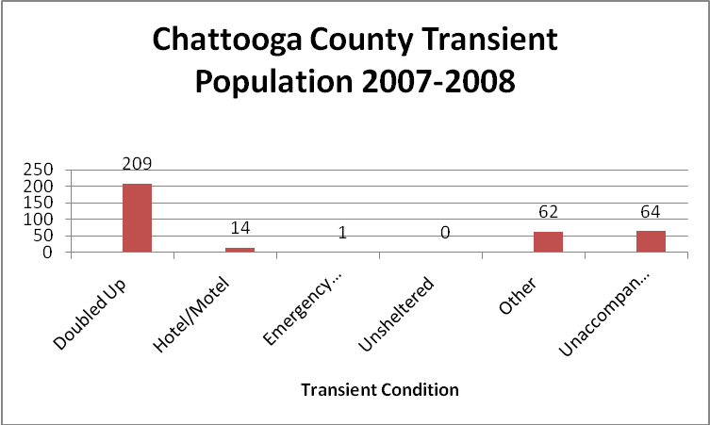
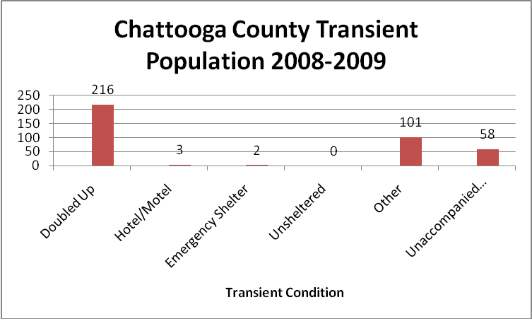
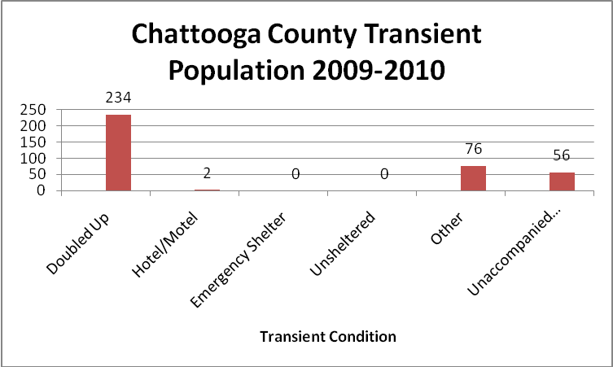
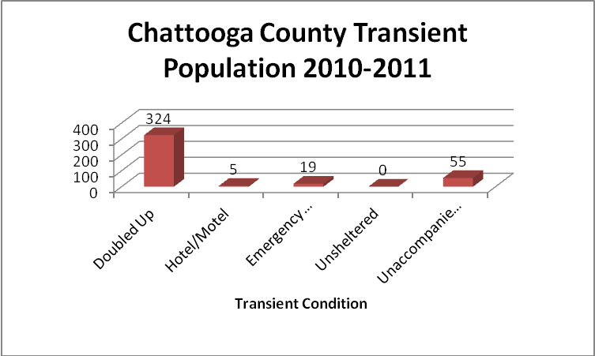
- These four charts illustrate the living situations of the Chattooga County transient population.

