

OVERVIEW

The McKinney-Vento Act defines and protects the rights of students in transition to enroll in, attend, and succeed in our public schools. Chattooga County Schools was approved by the State Board of Education for a three-year grant cycle of the Education of Homeless Children and Youth grant in 2010-2011 for an award amount of $49,433. The Evaluation summarizes the assistance provided during the 2011-2012 grant cycle.

DEFINITION

The McKinney-Vento Act provides educational services to any pre-school or school-aged student who lacks a fixed, regular, and adequate nighttime residence. The term transient includes:
- Children and youth who are sharing the housing of other people due to loss of housing, economic hardship, or a similar reason—“doubled up”
- Children and youth who are living in motels, hotels, trailer parks, or camp grounds due to the lack of alternative housing
- Living in emergency shelters or transitional shelters
- Abandoned in hospitals
- Awaiting foster care placement—temporary (approximately one year or less)
- Children and youth who have a primary nighttime residence that is a public or private place not designed for or ordinarily used as a regular sleeping accommodation for human beings
- Children and youth who are living in cars, parks, public spaces, abandoned buildings, substandard housing, bus or train stations, or similar settings
- Migratory children described in the above situations
- Unaccompanied youth are youth not in the physical custody of a parent or guardian.

ADDITIONAL RESOURCES

- National Association for the Education of Homeless Children and Youth– www.naehcy.org
- Georgia Department of Education– www.gadoe.org
- National Center on Homeless– www.serve.org/nche
- National Law Center for Homelessness & Poverty– www.nichp.org
- National Network for Youth– www.nn4youth.org
- Horizons for Homeless Children– www.horizonsforhomelesschildren.org
EVALUATION

Professional counseling proved to be the most successful activity providing counseling services to over half of the HCY population and serving nearly 40% more HCY than estimated in the original grant. Dr. Jennings met individually with 21 HCY at six schools, 22 HCY received art therapy at four schools, 9 HCY participated in Extended Family for Kids group at two schools, and 4 HCY met with Shannon Bond. In addition, School Counselors regularly served 129 HCY. Administrators, Counselors, Teachers, Nurses, and Community Agencies surveyed reported individual counseling as the number one need in the county. Randomly selected HCY surveyed reported group and individual counseling as the fourth and fifth highest need.
The distribution of school and hygiene supplies continued to be utilized. School supplies and hygiene products helped 89 HCY participate in school activities and projects; nearly 12% more than the estimated 15% in the original grant. Randomly selected HCY surveyed reported school supplies as the number one need. School staff surveyed reported school supplies as the number three need and community organizations reported supplies as the number two need.

Chattooga County identified 346 transient students in 2011-2012

TUTORING
- 41transient students out of 346 at six schools utilized tutoring through contracted Title I SES providers or after-school teacher tutoring. (This is 11.8%)

- From the letter grades recorded in Excel, our school found that 75.6% of students receiving tutoring assistance increased at least one letter grade quarterly (primarily in Math, Language Arts, and Reading or in the area being tutored).

- Of the 30 participating in tutoring that took the CRCT, 20 Met or Exceeded the standard in Language Arts (66.7%), 11 in Math (36.7%), and 22 in Reading (73.3%).

- In the original grant we strived for 10% of the total HCY to receive tutoring services with 85% of those receiving tutoring to improve one letter grade.

ASSISTANCE
- 93transient students received field trip assistance.

- 89 transient students received school supplies/hygiene products.

- 25 transient students received caps and gowns.

- 23 transient students received assistance to participate in band or Health Occupations Students of America (HOSA).

- 20 transient students received emergency clothing or athletic uniforms.

- 5 transient students received supplemental transportation services to remain in their school of origin.

- 1 transient student received Camp Goodtimes assistance.

COUNSELING SERVICES
- 185 transient students were provided counseling services. (This is 53.5%)
- 129 transient students were served consistently by School Counselors.
- 22transient students received art therapy through Blythe Mayfield at four schools.
- 21 transient students received individual counseling through Dr. Jennings at six schools.
- 9 transient students received group therapy through Extended Family for Kids at two schools.
- 4 transient students received small group communication building skills through Shannon Bond.
- Professional counseling was the most successful, far surpassing the goal of 15% of total HCY receiving professional counseling.

OTHER
- 63 transient students had over 15 absences this school year. (This is 18.2%)

2011-2012
346 Transient & Unaccompanied Youth

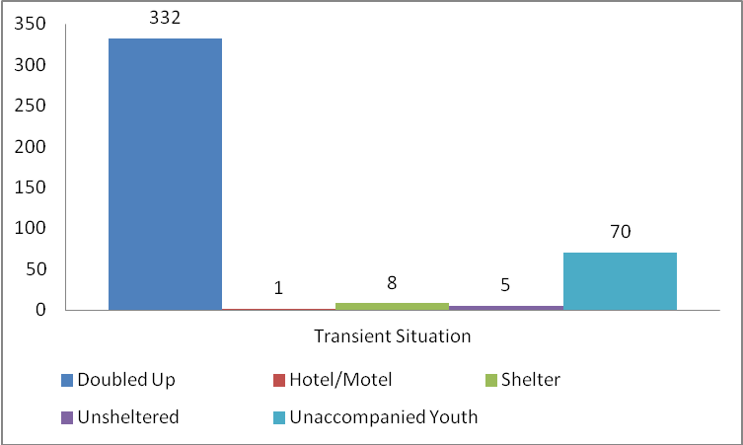

2010-2011
348 Transient & Unaccompanied Youth
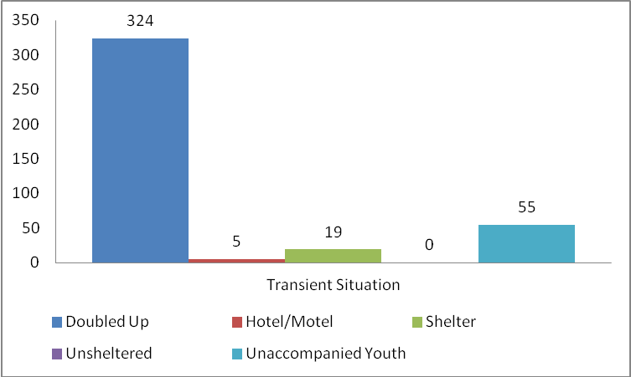

2009-2010
312 Transient & Unaccompanied Youth
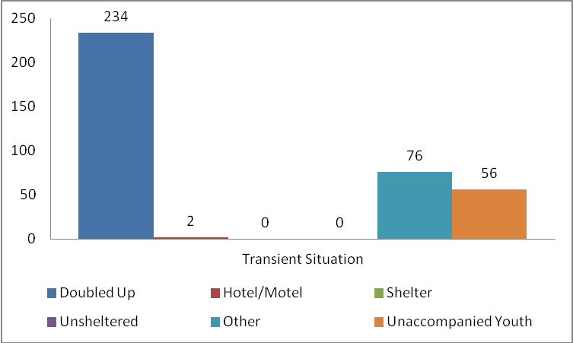

2008-2009
322 Transient & Unaccompanied Youth
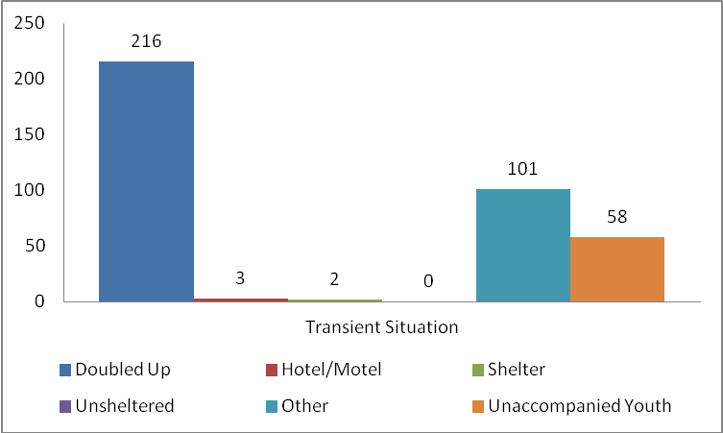

2007-2008
286 Transient & Unaccompanied Youth
